TEST new network code.

#1 Per discussion with Chen, for the networks we may want to have a function to download the graph data in a format that can be used by other tools. That is download the edge and node information into a format that can be imported by other tools (e.g. what formats does gephi use?, gephi.org)

#2 MAC Issue: Problem when pressing Start button for Network Analysis. Failed on .DS_Store, I think the software tried to read it as a directory –

Error: ENOTDIR: not a directory, scandir '/Users/jmtroy2/Documents/TEST_GRAPHQL/analytics-standalone/downloads/GraphQL/.DS_Store'
at Error (native)
at Object.fs.readdirSync (fs.js:952:18)
at readDIR (/Users/jmtroy2/Documents/TEST_GRAPHQL/analytics-standalone/scripts/helper.js:8:25)
at /Users/jmtroy2/Documents/TEST_GRAPHQL/analytics-standalone/routes/networkx/networkx.js:12:14
at Layer.handle [as handle_request] (/Users/jmtroy2/Documents/TEST_GRAPHQL/analytics-standalone/node_modules/express/lib/router/layer.js:95:5)
at next (/Users/jmtroy2/Documents/TEST_GRAPHQL/analytics-standalone/node_modules/express/lib/router/route.js:137:13)
at Route.dispatch (/Users/jmtroy2/Documents/TEST_GRAPHQL/analytics-standalone/node_modules/express/lib/router/route.js:112:3)
at Layer.handle [as handle_request] (/Users/jmtroy2/Documents/TEST_GRAPHQL/analytics-standalone/node_modules/express/lib/router/layer.js:95:5)
at /Users/jmtroy2/Documents/TEST_GRAPHQL/analytics-standalone/node_modules/express/lib/router/index.js:281:22
at Function.process_params (/Users/jmtroy2/Documents/TEST_GRAPHQL/analytics-standalone/node_modules/express/lib/router/index.js:335:12)

/Users/jmtroy2/Documents/TEST_GRAPHQL/analytics-standalone/downloads/GraphQL/.DS_Store
NOTE: this is a MAC problem, so when we test on hubzero it should not happen.



#3 Interactive Network Visualization (D3JS) – very nice!! Makes things easier to test.

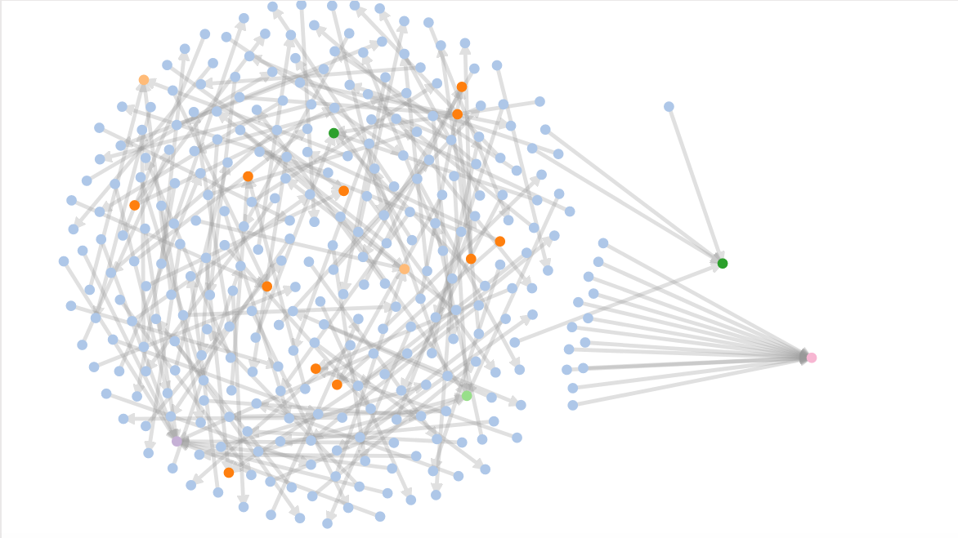

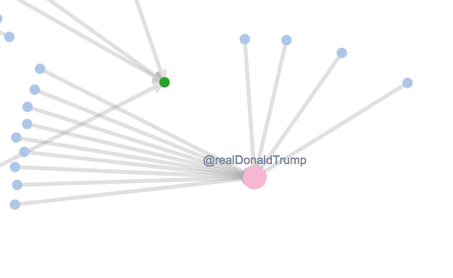

#4 Colorscale

Maybe add a few more words to tell users the colorscale relates to the degree of the nodes (how many edges it has)

#5 Network Analysis retweets

When looking at the data where “retweet from” was selected as the network relation, it looks like the tweets are “replies to” or “mentions”, and not “retweets”

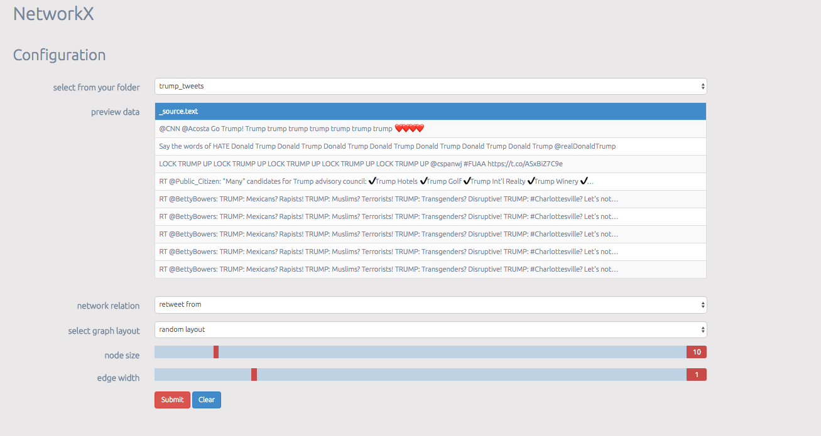

#5a

When I reviewed my data file, 20 users replied to @realDonaldTrump. So I think the 20 is just in the wrong place.

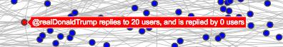

The D3JS looks good (below), In my screen print you can not see the arrow heads pointing to trump, but they are there
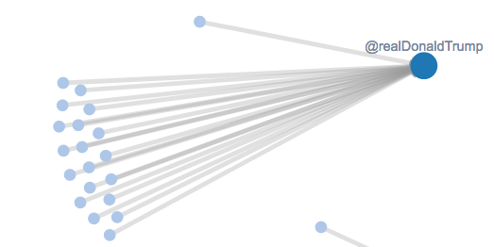

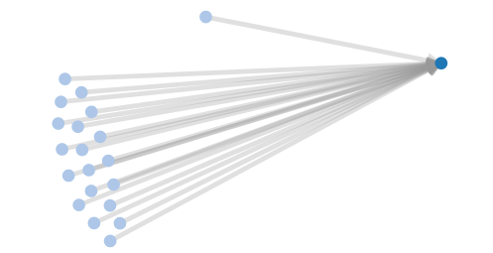

#5a continued.
Also, waynestuartrc replies to 1 user, and was replied to by 0, Maybe just the wording is causing confusion.

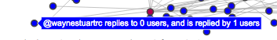

#5b – Chen, this may be an issue with an “_” in the screen name. The D3JC visualization only shows 6 replies to FoxNews, but there are seven per the “trump5” data, and also in the centrality metrics file (centrality.json). The screen name missing in the D3JS visualization is Llan_Llanos.

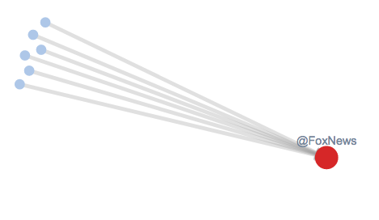

#6 Suggestion – I test the node size and edge width on Network Analsis and it works file, but maybe change labels to: node size (networkx), edge width (networkx), and Static Network Visualization (networkx). Just to help understand the difference between the parts that are plot.ly and D3JS.

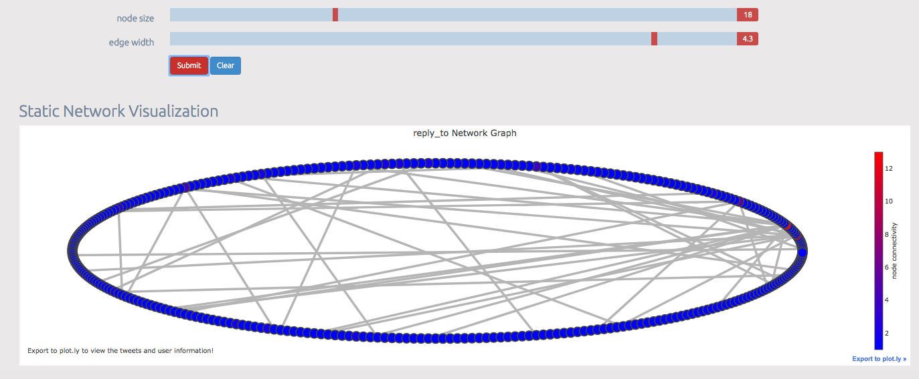

#7 filename illegal error message.
This happens when I press the “advanced” button, but do not put any text in the “Tweet keywords that you wish to search…” box.

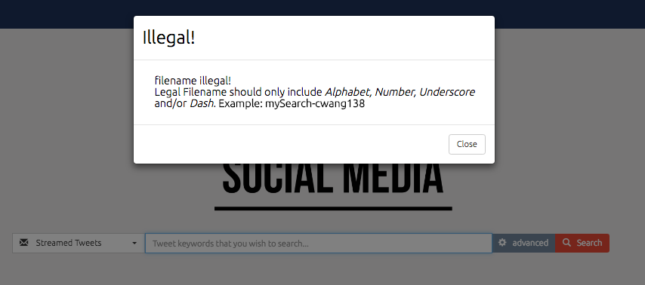

Test file management

Just an FYI: if opening a .csv file of saved tweets in Excel, the tweet id may lose precision in the rightmost 3 digits. The .csv file is fine, this is an excel issue. Work around may be to import file into excel instead of just doing an open.

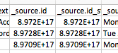

test VIEW button:

TEST 1 – looks good

